

PROG7311 PoE Part 3

Eben Mwema, ST10091324



BCA3

GROUP 1

VC Waterfall

Declaration

I Eben Nkulu Mwema declare that:

|  |  |
| --- | --- |
|  | SIGN |
| I have read the assessment rules provided in this declaration | E.N.M |
| This assessment is my own work. | E.N.M |
| I have not copied any other student’s work in this assessment. | E.N.M |
| I have not uploaded the assessment question to any website or App offering assessment assistance. | E.N.M |
| I have not downloaded my assessment response from a website. | E.N.M |
| I have not used any AI tool without reviewing, re-writing, and re-working this information, and referencing any AI tools in my work. | E.N.M |
| I have not shared this assessment with any other student. | E.N.M |
| I have not presented the work of published sources as my own work. | E.N.M |
| I have correctly cited all my sources of information. | E.N.M |
| My referencing is technically correct, consistent, and congruent. | E.N.M |
| I have acted in an academically honest way in this assessment. | E.N.M |

**Table of Contents**

**1. INTRODUCTION** 4

**2. PERFORMANCE IMPROVEMENT SUGGESTIONS** 4

2.1 Database Optimization 4

2.1.1 Vertical scaling 4

2.2 Ensuring acceptable performance 5

**3. SOFTWARE METHODOLOGY** 5

3.1 Methodology chosen 5

3.2 Reasoning for methodology 5

**4. DEVOPS IN PROJECT** 6

4.1 Reasoning for choosing DevOps 6

4.2 Usage of DevOps in our project 6

**5. FRAMEWORK FOR PROJECT** 7

5.1 Framework Recommendation 7

5.2 Reasoning for recommendations 7

**6. EXPLANATION OF PRODUCT TO MARKETERS** 8

6.1 Marketable description of product 8

6.2 Visual representation of product description 9

**7. LECTURER FEEDBACK** 9

7.1 Report Feedback 9

7.1.1 Structure feedback 9

7.1.2 Referencing feedback 12

7.1.3 General Feedback 16

7.2 Prototype Feedback 18

7.2.1 User experience feedback 18

**8. CONCLUSION** 21

REFERENCE LIST 22

**Table of Figures**

Figure 1: Product visuals (Eben, 2024) 9

Figure 2: Lecturer feedback 1 (The IIE, 2024) 10

Figure 3: Incorporated feedback 1 (Eben, 2024) 11

Figure 4: Lecturer feedback 2 (The IIE, 2024) 12

Figure 5: Incorporated feedback 2 (Eben, 2024) 13

Figure 6: Lecturer feedback 3 (The IIE, 2024) 14

Figure 7: Incorporated feedback 3 (Eben, 2024) 15

Figure 8: Lecturer feedback 4 (The IIE, 2024) 16

Figure 9: Incorporated feedback 4 (Eben, 2024) 17

Figure 10: Lecturer feedback 5 (The IIE, 2024) 18

Figure 11: Incorporated feedback 6 (Eben, 2024) 19

Figure 12: Incorporated feedback 5 (Eben, 2024) 20

# **1. INTRODUCTION**

Paraphrased from the IIE (2024) the purpose of this report is to explain and discuss the methodologies, tools and frameworks that our project will use as well as performance concerns.

# **2. PERFORMANCE IMPROVEMENT SUGGESTIONS**

## 2.1 Database Optimization

## 2.1.1 Vertical scaling

Percona (2024) states that vertical scaling involves upgrading your main server, by swapping old less powerful parts for newer, more powerful parts or by purchasing an entirely new, more powerful server.

As it stands currently, the Agri-Energy Connect database server is being ran on an old 2018 desktop (student machine) that was not originally intended to run as a server. If 1000 farmers simultaneously try to add their crop products information using the Agri-Energy Connect Platform, that 2018 Desktop will not be able to handle all those incoming requests to add products to the database and it will result in either, the farmers waiting for unreasonably long times for their products to be added to the database or the server crashing and not adding any of the requested products to the database. This can be mitigated by purchasing a more powerful prebuilt server (more feasible) such as the Lenovo ThinkSystem ST50 V2 Server, which according to Lenovo (2024) is an Entry level server or by purchasing server components separately and assembling the parts ourselves (less feasible).

## 2.2 Ensuring acceptable performance

The IIE (2024) the Agri-Energy Connect team can use for loops to measure how long queries (requests to get data from the database) are taking to execute in milliseconds. With this knowledge, the development team can either leave the queries as is if there are no performance concerns or they can try various database optimisation methods such as indexing or caching of regularly accessed database data that seldomly changes. Development team should constantly measure and monitor how long it takes for tasks regarding the Agri-Energy Connect platform to execute. For example, there is a clear performance issue if it takes one minute to retrieve a list of 10 farmers from the database. It should not take more than 5 seconds to execute such a query.

# **3. SOFTWARE METHODOLOGY**

## 3.1 Methodology chosen

I would recommend Agri-Energy Connect to use the Scrum methodology (an agile framework) which uses an adaptive and iterative software development approach with a strong emphasis on team collaboration (Gido, Clements, Baker, Harinarain & Eresia-eke, 2024).

## 3.2 Reasoning for methodology

The scrum methodology will increase development speed by forcing the Agri-Energy Connect team to develop smaller iterations of specific requirements or features within a specific period called sprints (usually 1 to 4 weeks) (Gido et al., 2022). For example, creating, connecting and using a database for the farmer login page within a week.

Customer satisfaction can also be increased by demonstrating the iterations developed to the product owner (a customer representative) who will provide feedback on the work done during the sprint (a short period, usually 1 to 4 weeks) and ensure that the development team is aware of the needs of the farmers and green energy technology providers (Gido et al., 2022). For example, if the product owner thinks the process of adding farmer products is too complex, they can voice their opinions during the sprint review meeting (meeting for reviewing work done during sprint).

# **4. DEVOPS IN PROJECT**

## 4.1 Reasoning for choosing DevOps

Yes, I would recommend DevOps for this project because it aligns with principles of the software methodology chosen above (Scrum). Both have a strong emphasis on team collaboration and iterative software development lifecycles (Atlassian, 2024).

The DevOps tools will enable the Agri-Connect Energy Team to deliver more stable product increments (iterations of software) during our sprints by automating the testing processes (Atlassian, 2024).

## 4.2 Usage of DevOps in our project

Agri-Energy connect can use a continuous integration tool like Git to keep track of and merge codebase changes between various developers of the team. For example, if a developer just finished coding the feature to add new farmer from the employee portal, that developer can then commit and push their code to a GitHub repository using git and another developer can pull those changes to the codebase and start working on another part of the application like the delete function for farmer products. Once they are done working on that, then can once again commit and push their code and the cycle begins again.

Using GitHub Actions, we can automate testing for all the code that gets pushed to our GitHub repository by coding predefined tests and making them run whenever an event regarding our GitHub repository occurs (GitHub, 2024). For example, we could make the method that deletes the farmer profile, return a “true” if the profile was successfully deleted and a “false” if the profile deletion process was unsuccessful. We can then write a test that will compare if that method returns a true whenever a farmer profile is successfully deleted.

# **5. FRAMEWORK FOR PROJECT**

## 5.1 Framework Recommendation

I would recommend The Open Group Architecture Framework (TOGAF).

## 5.2 Reasoning for recommendations

White (2022) TOGAF aligns with the agile methodology chosen above (Scrum), therefore the Agri-Energy Connect team will not have to evaluate and choose another software methodology suitable for TOGAF.

White (2022) TOGAF will help align the goals of the business department of Agri-Energy Connect with the goals of the IT department of Agri-Energy Connect by providing guidelines on how to define and organise requirements before the project begins. For example, the business goal for Agri-Energy Connect might be to improve auditing of expenses. TOGAF will provide guidelines on how the business department can communicate with the IT department so that the IT department can develop a robust system that will allow the Agri-Energy Connect employees record server expenses quickly and easily for example.

White (2022) TOGAF provides a guideline on how to document and store key information of the business. In this case, TOGAF will provide a unified language and documentation style that all Agri-Energy Connect developers can follow when documenting their code. This will help new and existing developers of Agri-Energy Connect, understand how specific functions of the Agri-Energy Connect platform work and how to fix issues regarding those functions in the future. This will reduce the time spent learning how functions work and speed up the process of implementing new features and fixing new features.

# **6. EXPLANATION OF PRODUCT TO MARKETERS**

## 6.1 Marketable description of product

The prototype built is a powerful, lightweight website-based application that allows farmers to seamlessly add, edit, delete and view products as they wish. Each farmer can access this website-based application from anywhere around the world, at any time, on any device so long as they have a browser installed and an active internet connection.

## 6.2 Visual representation of product description

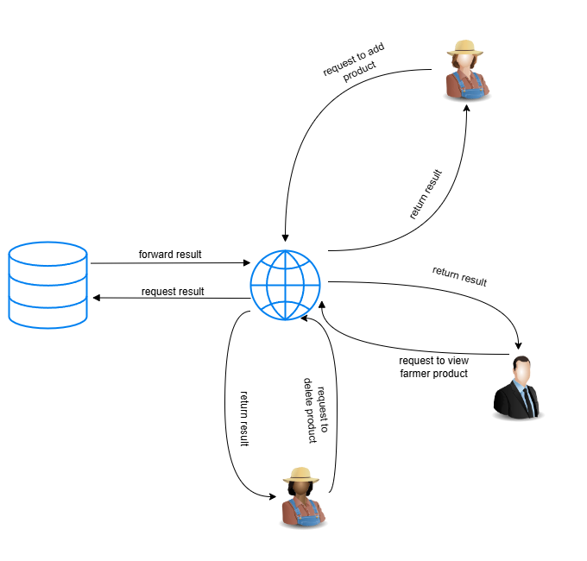

Figure 1: Product visuals (Eben, 2024)

# **7. LECTURER FEEDBACK**

## 7.1 Report Feedback

### 7.1.1 Structure feedback

Lecturer feedback:

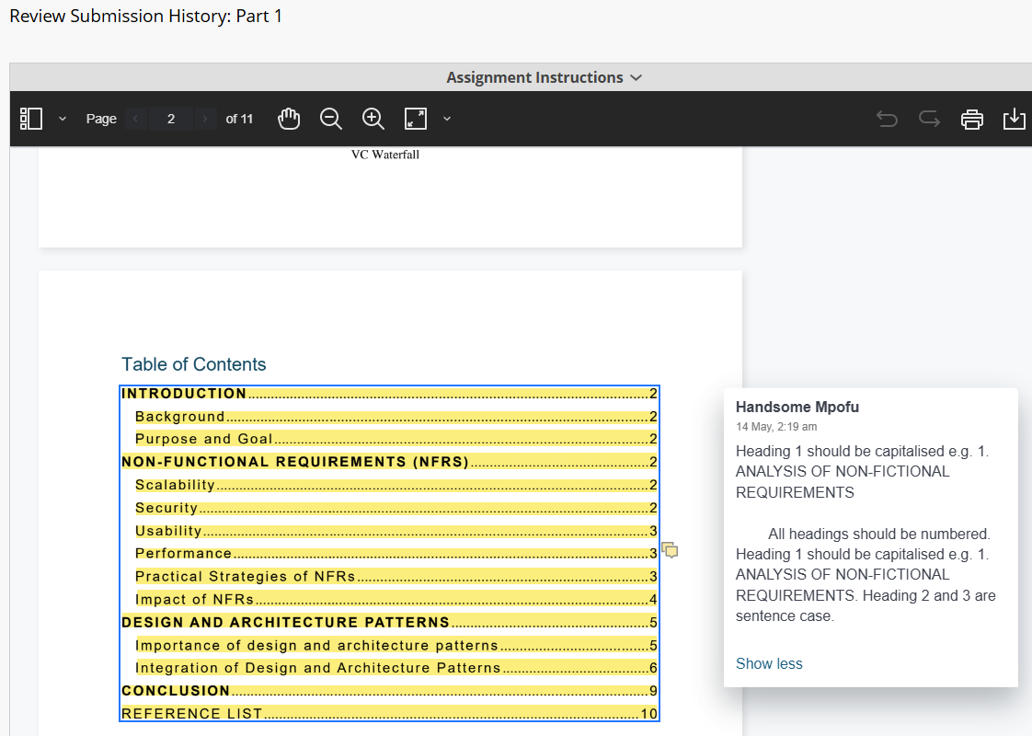

Figure 2: Lecturer feedback 1 (The IIE, 2024)

Incorporated feedback:

Figure 3: Incorporated feedback 1 (Eben, 2024)

### 7.1.2 Referencing feedback

Lecturer feedback:

Figure 4: Lecturer feedback 2 (The IIE, 2024)

Incorporated feedback:

Figure 5: Incorporated feedback 2 (Eben, 2024)

Lecturer feedback:

Figure 6: Lecturer feedback 3 (The IIE, 2024)

Incorporated feedback:

Figure 7: Incorporated feedback 3 (Eben, 2024)

### 7.1.3 General Feedback

Lecturer feedback:

Figure 8: Lecturer feedback 4 (The IIE, 2024)

Incorporated feedback:

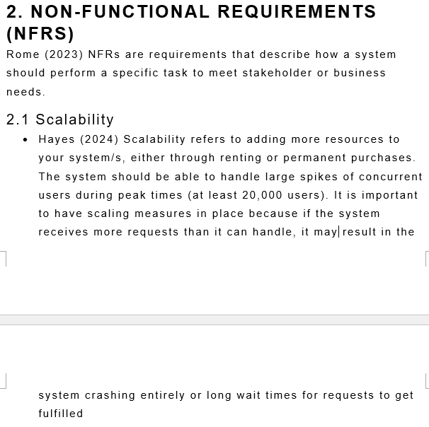

Figure 9: Incorporated feedback 4 (Eben, 2024)

## 7.2 Prototype Feedback

### 7.2.1 User experience feedback

Lecturer feedback:

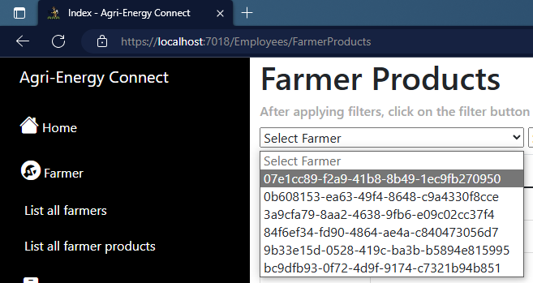

Figure 10: Lecturer feedback 5 (The IIE, 2024)

Incorporated feedback:

Figure 12: Incorporated feedback 5 (Eben, 2024)

Lecturer feedback:

The IIE (2024) include an SQL script containing preloaded data for the database.

Incorporated feedback:

An SQL script file has now been included and is located in the “SQL Preloads” folder inside the “Updated Part 2” folder.

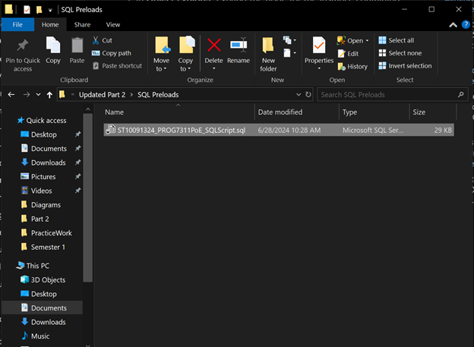

Figure 11: Incorporated feedback 6 (Eben, 2024)

# **8. CONCLUSION**

This report has discussed in detail what methodology, frameworks, tools, practices and performance improvements would be suitable for the Agri-Energy Connect platform. A marketable description of the Agri-Energy Connect platform has also been provided.

# REFERENCE LIST

Atlassian, 2024. What Is DevOps, Atlassian, [n.d.]. [Blog]. Available at: <https://www.atlassian.com/devops> [Accessed 26 June 2024].

Gido, J., Clements, J., Harinarain, N. and Eresia-eke, C. 2022. *Successful Project Management in South Africa*.2nd ed. Andover: Cengage Learning EMEA.

GitHub. 2024. About continuous integration, GitHub Docs, [n.d.]. [Blog]. Available at: <https://docs.github.com/en/actions/automating-builds-and-tests/about-continuous-integration> [Accessed 26 June 2024].

Lenovo. 2024. ThinkSystem ST50 V2 Tower Server, [n.d.]. [Online]. Available at: <https://www.lenovo.com/us/en/p/servers-storage/servers/towers/thinksystem-st50-v2/len21ts0004> [Accessed 26 June 2024].

Percona, 2024. How to Improve Database Performance: The Ultimate Guide, Percona, 18 April 2024. [Blog]. Available at: <https://www.percona.com/blog/ultimate-guide-to-improving-database-performance/> [Accessed 26 June 2024].

The IIE. 2024. Programming 3A [PROG7311 Learn]. The Independent Institute of Education: Unpublished.

The IIE. 2024. Programming 3A [PROG7311 Module Manual]. The Independent Institute of Education: Unpublished.

The IIE. 2024. Programming 3A [PROG7311 Portfolio of Evidence]. The Independent Institute of Education: Unpublished.

White, S. 2022. What is TOGAF? An enterprise architecture methodology for business, CIO, 30 May 2022. [Blog]. Available at:<https://www.cio.com/article/228328/what-is-togaf-an-enterprise-architecture-methodology-for-business.html> [Accessed 27 June 2024].